**REACT ASSIGNMENT**

Module – 3 (JavaScript Essentials)

1. What is React Js?

Ans. React js is an open-source javascript library for building user interfaces or user interface components. It was developed by Facebook and is widely used for creating interactive and dynamic front-end web applications.

2. What is NPM in React Js?

Ans. NPM stands for Node Package Manager, is a package manager for javascript. It is used to manage and install libraries, frameworks, and tools in a Node.js environment.

3. What is Role of Node Js in react Js?

Ans. NodeJs provides NPM to install open-source packages and also people prefer to use JSX format while writing React Js. So Node Js provides efficient environment for creating React by providing useful tools.

4. What is CLI command In React Js?

Ans. React has its own command-line interface (CLI) commands. However, these CLI commands are currently only used to create a passable version of a react application using the command line.

npm create-react-app appname

5. What is Components in React Js?

Ans. A component is a reusable and self-contained piece of code that defines a part of a user interface. Components are the building blocks of a React application, and they encapsulate the logic and presentation of a particular part of the UI

Components are the 2 types functional components & class components.

Functional components

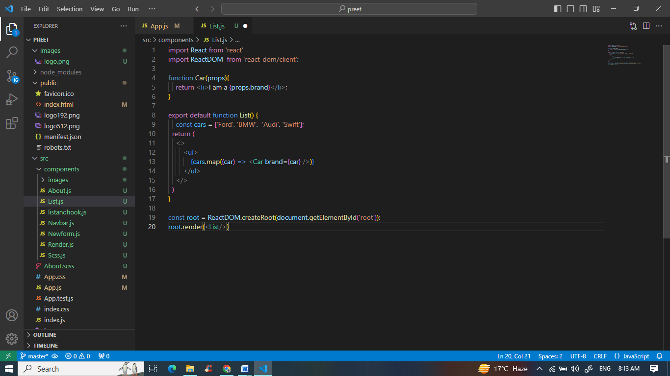

Class components  
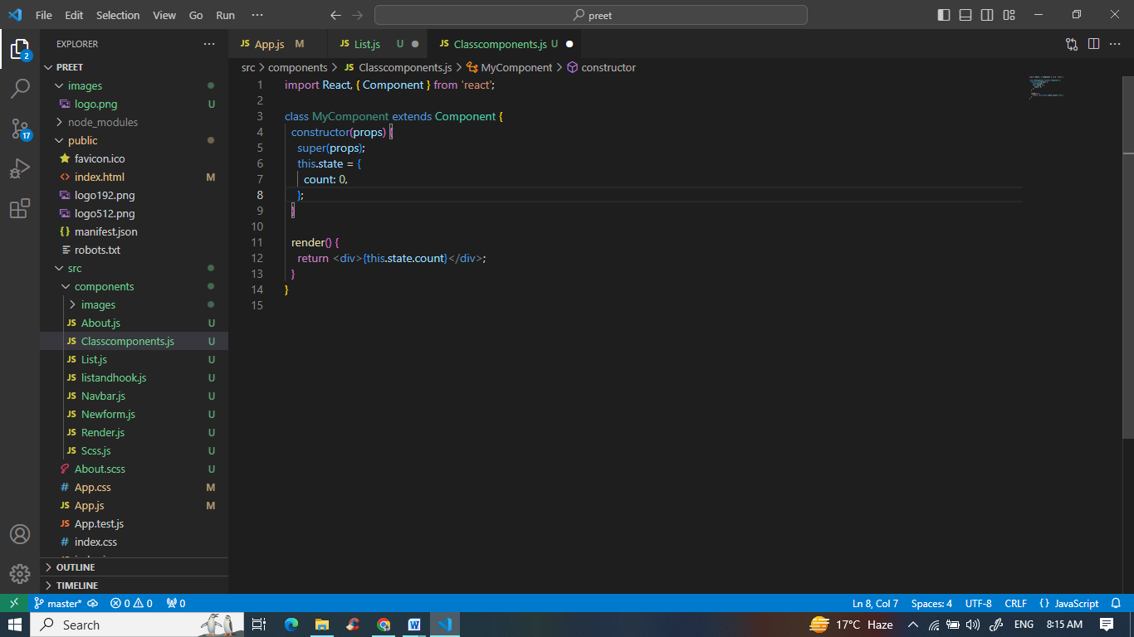

6. What is Header and Content Components in React Js?

Ans. A header is a section at the top of a page that display site name and navigation.

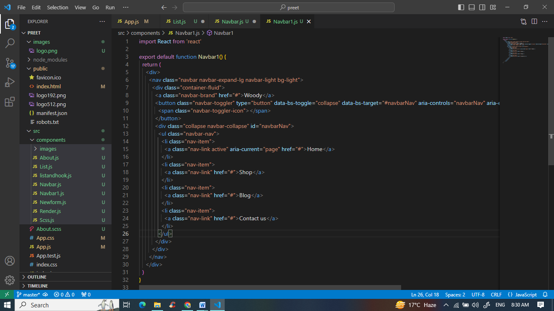

The content components are a very widely based on the specific requirement of the application. It include text, image, form and other elements and other components.

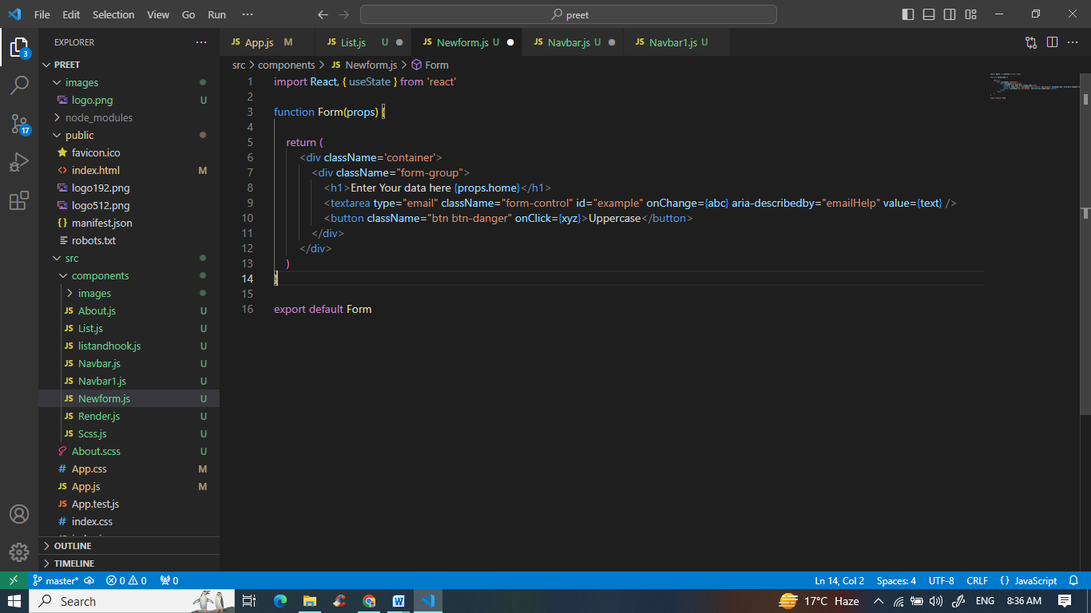

7. How to install React Js on Windows, Linux Operating System? How to install NPM and How to check version of NPM?

Ans. > Open Terminal(Command Propmt or Powershell).

> Go into your desired location where you want to start react app by using

‘cmd’ command in prompt.

> Use the command ‘npm create-react-app projectname’.

8. How to check version of React Js?

Ans. by opening the package.json file.

9. How to change in components of React Js?

Ans. > Props is used to change in components of React Js. props can be defined as an argument in child component.

> we can change that child component in another component by using their arguments as a property while defining child component.

10. How to Create a List View in React Js?

Ans. 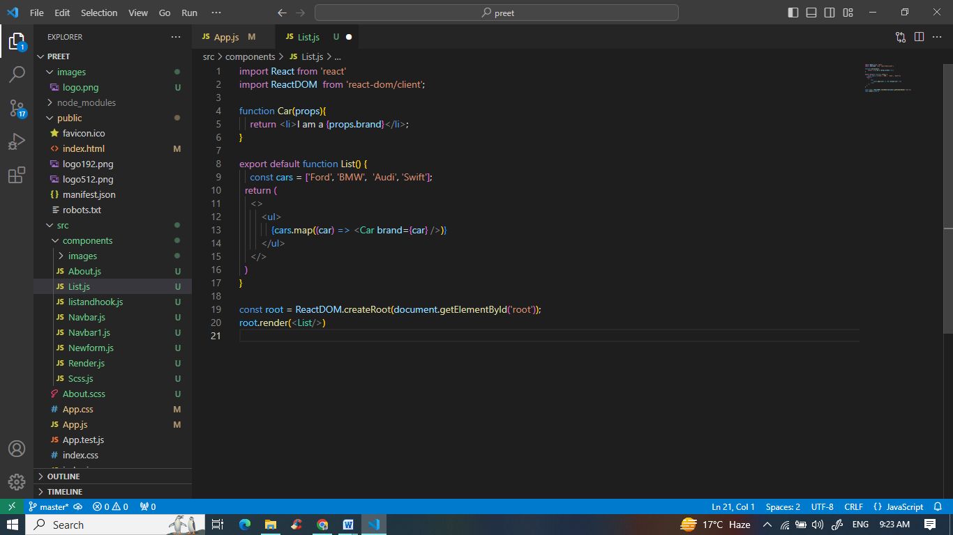

11. Create Increment decrement state change by button click?

Ans. 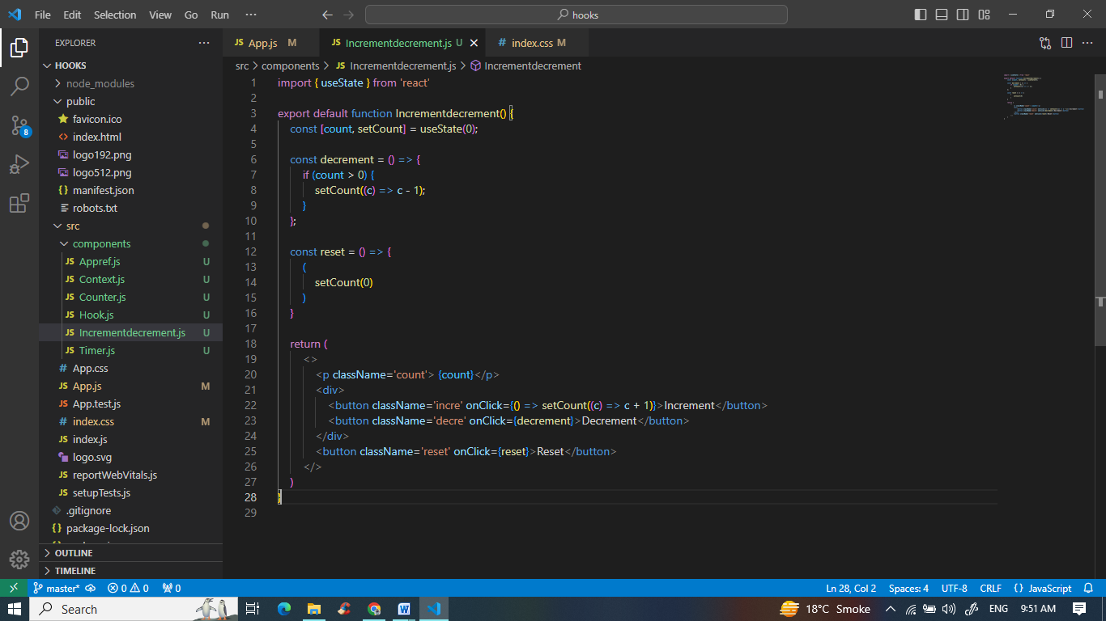

CSS  
